 SCHOOL *of* BUSINESS AND TECHNOLOGY

Department of Engineering and Aviation Sciences

**Smart Delivery**

**Kevin Harper**

**Eli Nbede**

**Montraz Oliver**

Advisor: Dr. Zhang

May 4, 2020

Design of Autonomous Food Delivery Vehicle

By

Kevin Harper, Eli Nbede, and Montraz Oliver

Submitted to the Department of Engineering and Aviation Sciences in partial fulfillment of the requirements for the degree of Bachelor of Science in Engineering at the UNIVERSITY OF MARYLAND EASTERN SHORE

Date

The author hereby grants the University of Maryland Eastern Shore permission to reproduce and distribute publicly, paper and or electronic copies of this document in whole or in parts.

Authors Kevin Harper, Eli Nbede, and Montraz Oliver

Signature

Date

Department of Engineering and Aviation Sciences

Certified by

**LIST OF CONTENTS**

**List of Contents……………………………………………………………………………**

**List of Figures…………………………………………………………………………………………**

**List of Tables………………………………………………………………………………….**

**Abstract…………………………………………………………………………………………………………**

**1 Introduction………………………………………………………………………………………………**

**1.1 Background/Motivation………………………………………………………………………………….**

**1.2 Objective……………………………………………………………………………………………….**

**1.3 Design Requirements……………………………………………………………………**

**1.4 Design Constraints…………………………………………………………………………..**

**2. Project Description……………………………………………………………………..**

**2.1 System Description………………………………………………………………………...**

**2.2 System Diagram……………………………………………………………………………...**

**3. Implementation Plan…………………………………………………………………………….**

**3.1 Tasks………………………………………………………………………………………………….**

**3.2 Team Organization……………………………………………………………………………….**

**3.3 Timeline/Milestones/Delivery Plan…………………………………………………..**

**4. Implementation…………………………………………………………………………………...**

**4.1 Implementation of Task 1…………………………………………………………………….**

**4.2 Implementation of Task 2……………………………………………………………………..**

**4.3 Implementation of Task 3……………………………………………………………………….**

**4.4 Implementation of Task 4………………………………………………………………………….**

**4.5 Implementation of Task 5………………………………………………………………………...**

**4.6 Implementation of Task 6………………………………………………………………………..**

**4.7 Implementation of Task 7………………………………………………………………………...**

**5. Conclusion**

**LIST OF FIGURES**

Figure 1…………………………………………………………………………………………

Figure 2…………………………………………………………………………………………..

Figure 3…………………………………………………………………………………………………

Figure 4…………………………………………………………………..

Figure 5…………………………………………………………………………………….

Figure 6……………………………………………………………………………………………….

Figure 7…………………………………………………………………………………………………

Figure 8…………………………………………………………………………………………………

Figure 9……………………………………………………………………………………………

Figure 10……………………………………………………………………………………………

**LIST OF TABLES**

Table 1. PROJECT TIMELINE AND DELIVERY PLAN……………………………………………N/A

**ABSTRACT**

**CHAPTER 1. INTRODUCTION**

Autonomous self-driving vehicles are growing exponentially in popularity within new age technology. There are only a few level 5 self-driving vehicles that require no human activation to drive. These self-driving cars are being used to transport goods and people around the world. Furthermore the electric car is preferred more often because it offers economic, global, and environmental benefits. The car that we plan to design will deliver food to people autonomously.

**Background/Motivation**

On the campus of the University of Maryland Eastern Shore there are many students that worry about their next meal and how they are going to get hold of it in a timely fashion. A college student has numerous responsibilities on their table, which limits their ability to obtain food in an ideal time.Throughout an average college student's day they might have at least 3 to 6 classes per day, extracurricular activities if they are an athlete or in some type of group, and they have to study to stay on top of their grades. Furthermore, most colleges have freshmen who are not allowed to have cars. And if any student who drives a car must pay a lot of money for parking and fees. This limits the amount of college students with cars and increases the amount of college students walking around campus. “Among the 214 National Universities that reported these data to U.S. News in an annual survey, the average percentage of students who brought cars to campus in the 2016-2017 academic year was 46.8 percent”.

When college students are in their dorm after a long day of classes and stressful lecturing. They still must do homework and study for their classes. At that point they are tired of walking and going to get some food that is at least .4 miles away. The combination of the gruesome schedule of college students makes and the tireless walking around campus makes it hard for college students to eat food when it's offered.

What if it was possible to send Campus Universities dining services to students around to their dorm room or any location they may possibly be located. This would allow campus living students to have the option to not worry about receiving food without stopping their homework and walking half a mile to their cafeteria or dining services. An Autonomous Food Delivery System can be created to deliver food around the campus to any recipient, preferably college students living on campus.

At the University of Maryland Eastern Shore students are offered food at the locations including Students Service Center, Engineering & Aviation Sciences Complex, Hawk’s Nest, Waters Hall. In the Students Service Center they offer students plateau dining, and oasis staff dining. The UMES campus offers food, but they have no form of delivery options for students to receive food on campus. Furthermore, college students often argue and complain about the food they receive from the cafeteria. This leads them to eat the chick-fil a food that the university provides or any other dining services other than the cafeteria options. There should also be an option for students to choose the food they want to receive via delivery options. Instead of dreading the taste of the food they hate, they can designate their specified food to come to their location.

The idea of creating an autonomous food delivery car was sparked by the Starship Delivery Robot. The Starship Robot is a six-wheeled ground robot that can navigate streets and sidewalks, where they offer on-demand package delivery for consumers and businesses. The Starship Robot was created and operated by Starship Technologiesin July of 2014.

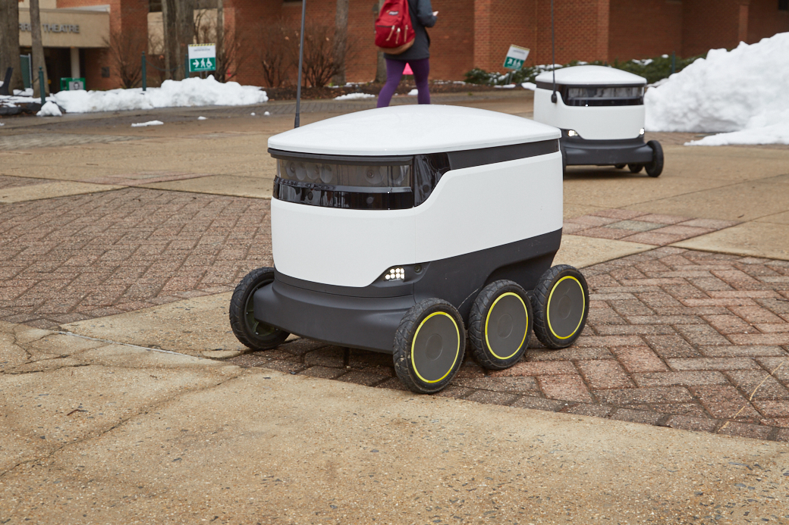

*Figure 1: This figure shows the Starship Delivery Robot founded by Starship Technologies*

**Objective**

Design an autonomous electric car that can deliver dining services around campus universities

**Design Requirements**

1. Carry up to eight pounds of food
2. Will deliver one meal at a time
3. Open and close of food compartment
4. Navigation
5. Speed of 5-10 mph
6. Detect and drive on the sidewalk
7. Detect crosswalk
8. Detect Objects
9. Phone Application
   1. Payment System
   2. Ordering System
   3. Food Tracking
   4. SMS
   5. client App
   6. received information

**Design Constraints**

1. Tires might not be able to withstand certain road conditions
2. Driving in the rain, snow, and thunderstorms
3. System is incapable of going up stairs or ramps
4. Driving on roadways

**CHAPTER 2. PROJECT DESCRIPTION**

**System Description**

The core system of the electric car is the raspberry pi that is interfaced with the camera module, lidar sensor, and the Arduino. The driving parameters from the camera and lidar such as object detection and lane detection is sent to the Arduino. The Arduino uses the parameters from the raspberry pi to control the car. Also the Gps is interfaced with the Arduino to send and receive location parameters from the website location. The arduino uses those gps commands to drive the car to the designated location. Arduino will notify the website when a designated location is achieved through telemetry, so it can then send an SMS to the recipient.

**System Diagram (or Flow Chart)**

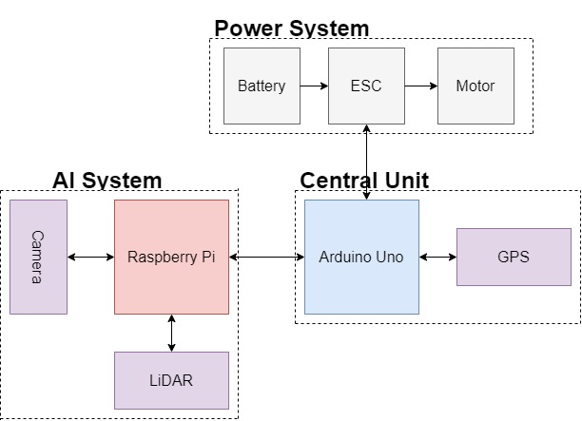

*Figure 2: Electrical System Diagram*

**CHAPTER 3. IMPLEMENTATION PLAN**

**Tasks**

Task1: Vehicle Structural Design

Subtask 1.1: CAD of Structure

Subtask 1.2: Implement Structure

Subtask 1.3: Design Lock System

Task 2: Design Electrical Power System

Subtask 2.1: Identify electrical components

Subtask 2.2: Connect Components

Subtask 2.3: ESC Programming on Arduino

Task 3: APP Design

Subtask 3.1: Create Ordering System

Subtask 3.2: Design Payment System

Subtask 3.3: Design Food Tracking System

Subtask 3.4: Design SMS

Task 4: Design of the Artificial Intelligence System

* Subtask 4.1: Gather Training Data
  + Camera: Capture Images
  + Annotator: Annotate Images
* Subtask 4.2: Train model
  + GPU: Pre-Processing
  + GPU: Model Training
* Subtask 4.3: Deploy Pre-Trained Neural Network
  + Raspberry Pi Camera: Capture Image
  + Raspberry Pi: Predict Image
* Subtask 4.4: Send Control and Steering Commands
  + Design Heading Direction Calculations
  + Design Serial Protocol

Task 5: Design Lidar System

Subtask 5.1: Design Program for LiDAR sensor

Subtask 5.2: Design connection for LiDAR sensor

Subtask 5.3: Send control and steering commands

Task 6: Navigation

Subtask 6.1:Extract Geographic Coordinate Units

Subtask 6.2: Program GPS on Arduino

Subtask 6.3: Program Compass on Arduino

Task 7: System Testing, evaluation, and enhancement

Subtask 7.1: Test Design Requirements

Subtask 7.2: Evaluate and apply changes if necessary

Subtask 7.3: Repeat process

**Team Organization**

*3.2.1* ***Responsibility of Kevin Harper***

Task 1, Task 2, Task 5, Task 6 Task 7

*3.2.2* ***Responsibility of Montraz Oliver***

Task 1, Task 4, Task 5, Task 6,Task7

*3.3.3* ***Responsibility of Eli Nbede***

Task 1, Task 3, Task 5, Task 6, Task 7

**Timeline/Milestone/Delivery Plan**

**Table 1. PROJECT TIMELINE AND DELIVERY PLAN**

|  |  |  |  |  |
| --- | --- | --- | --- | --- |
| Time | Tasks | | | Comments |
| Montraz Oliver | Eli Nbede | Kevin Harper |
| Week 1-3 | Subtask 1.1 | Subtask 1.1 | Subtask 1.1 |  |
| Week 4 -7 | Subtask 4.1 | Task 3 | Subtask 2.1, 6.1 |  |
| Week 8 - 11 | Subtask 4.2 & 5.1 | Task 3 | subtask 5.1 |  |
| Week 12-13 | Subtask 1.2, Subtask 5.2 | Subtask 1.3, Task 3 | Subtask 1.2 ,Subtask 2.2 |  |
| week 14-16 | Subtask 4.3-4.4 | Task 3  Subtask 2.3 | subtask 6.2  subtask 2.3 |  |
| week 17-18 | Subtask 4.3-4.4 | Subtask 6.3 | subtask 6.3 |  |
| week 19-22 | Task 7 | Task 7 | Task 7 |  |

**CHAPTER 4. IMPLEMENTATION**

**Implementation of Task 1.**

*4.1.1. Implementation of Subtask 1.1*

*4.1.2. Implementation of Subtask 1.2*

*4.1.3. Implementation of Subtask 1.3*

*……..*

**Implementation of Task 2.**

*4.2.0 Implementation of Subtask 2.0*

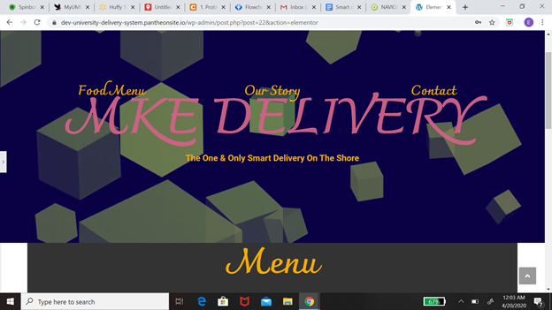

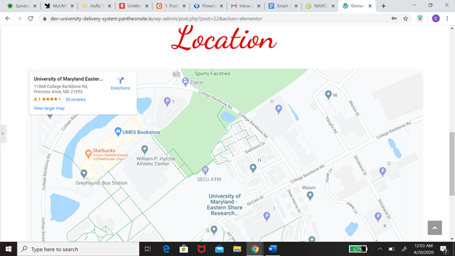

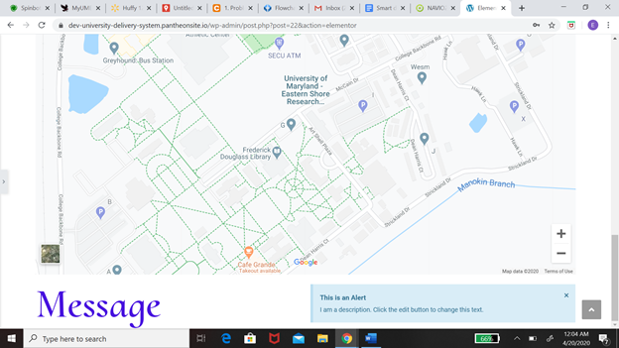

*The task at hand was basically designing a system where customers are able to order from and the employees are able to receive this order. This message from the customer will come with two key information one being the location of the customer and another being in the order that the customer please. My first solution with the problem at hand was to create a website using Pantheon. One of the mean reasons I chose pantheon was because it is User-friendly. We should allow me to come to the situation with no experience with this application. The approach I took from there was to design the function of the website which includes the menu, the contact information, location, and basket. The menu was based on the Chick-fil-A menu that is already online so all I needed was a plug-in but one of the problems I ran into while doing that was there is more than one restaurant on campus. So how would I be able to imply multiple menus on this website. After that, I worked on contact information which would include Our number. From there I want to create the location and the check out basket. I still had some consideration for the website which includes how to install more than one menu at a time and also have the GPS system track the food order. I was never able to add the Message system to the website before moving away from this idea.*

[*https://dev-university-delivery-system.pantheonsite.io/wp-admin/post.php?post=22&action=elementor*](https://dev-university-delivery-system.pantheonsite.io/wp-admin/post.php?post=22&action=elementor)

*4.2.1 Implementation of Subtask 2.1*

*The next path after leaving the website was to create a cell phone app. Some of the reasons why I decided to work with a cell phones app was that it is way more versatile. when it comes to adapt to different applications like the problem I have with the messaging system and including the map on the website. The next step to the solution would be to create an application just only for the customer. Features on this application would include placing orders, allowing payments sharing location, messaging System. I will be going in more detail about every single feature on this app but first I need to explain the steps and procedures the App will take to solve these problems. Now I'm going to explain my flow chart which basically shows my thinking process on creating the application. When you first open the application it's going to take you to the welcome page and on that page, it's going to include sign-in or sign-up. If you already have an account with us you will be able to sign in to the app. if not you will have the option to sign up. After you successfully sign in to the app it will take you to the homepage. The information that will be included on the homepage would be a restaurant, Shopping cart and you will be able to search the app from the homepage. Each option will take you to a different page. If you decide to click the restaurant page you would be able to select the restaurant you want to order from and once you do that it would take you to the menu on the restaurant. if you’re not satisfied there will be an if statement that will give you the option to take you back to the main restaurant page that has all the different choices. The next part of this app would be the payment which would include the information like credit or debit card information and name of the person who is buying the food if you have a promo you can also include that into Payment. From there it’s going to take you to a map of the campus and you will pick your location on the map. which would all be included in your messaging system and your receipt and all that information will be sent to the business you order from and you will receive a text saying the order is complete.*

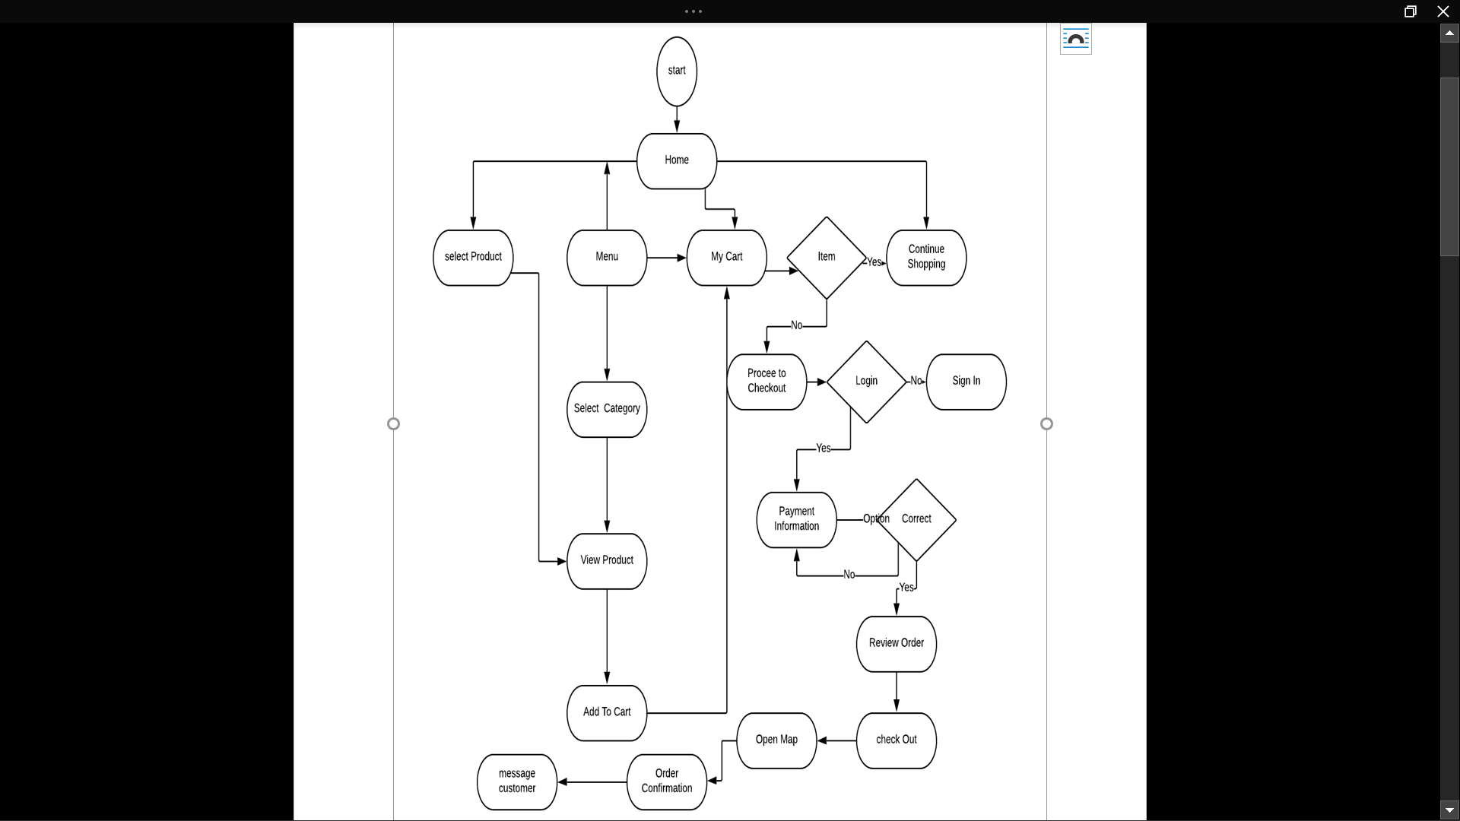

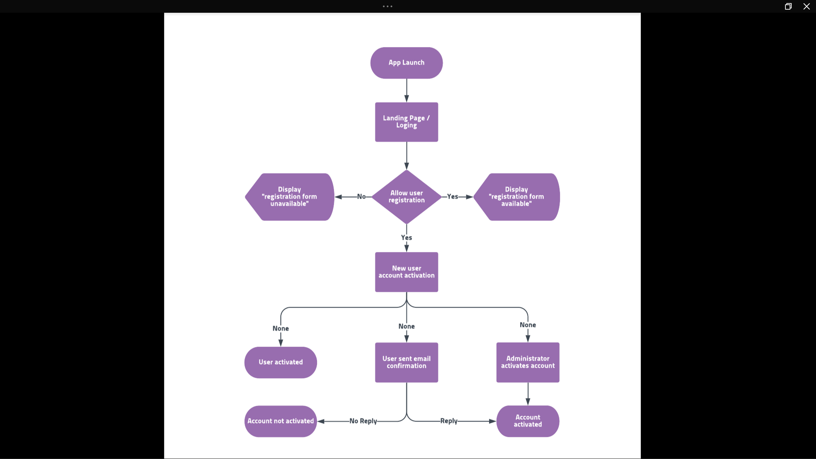

*4.2.2 Implementation of Subtask 2.2*

*4.2.3 Implementation of Subtask 2.3*

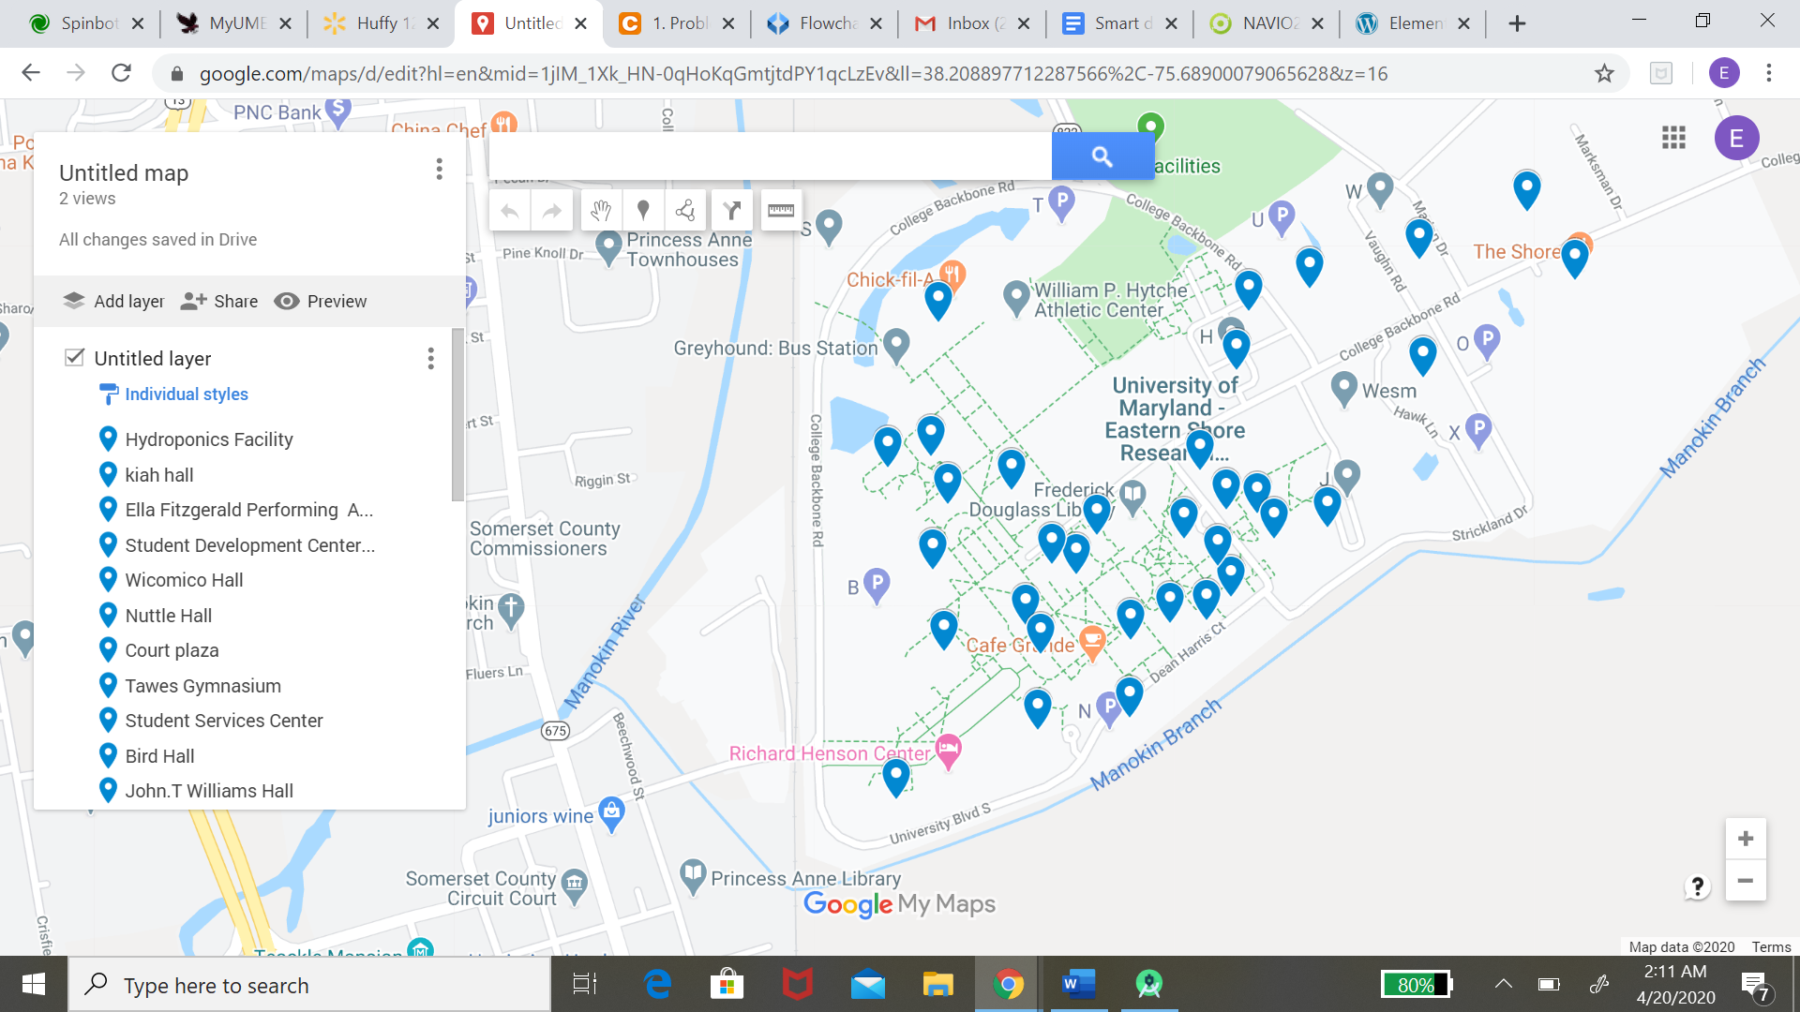

*4.2.4 Implementation of Subtask 2.4*

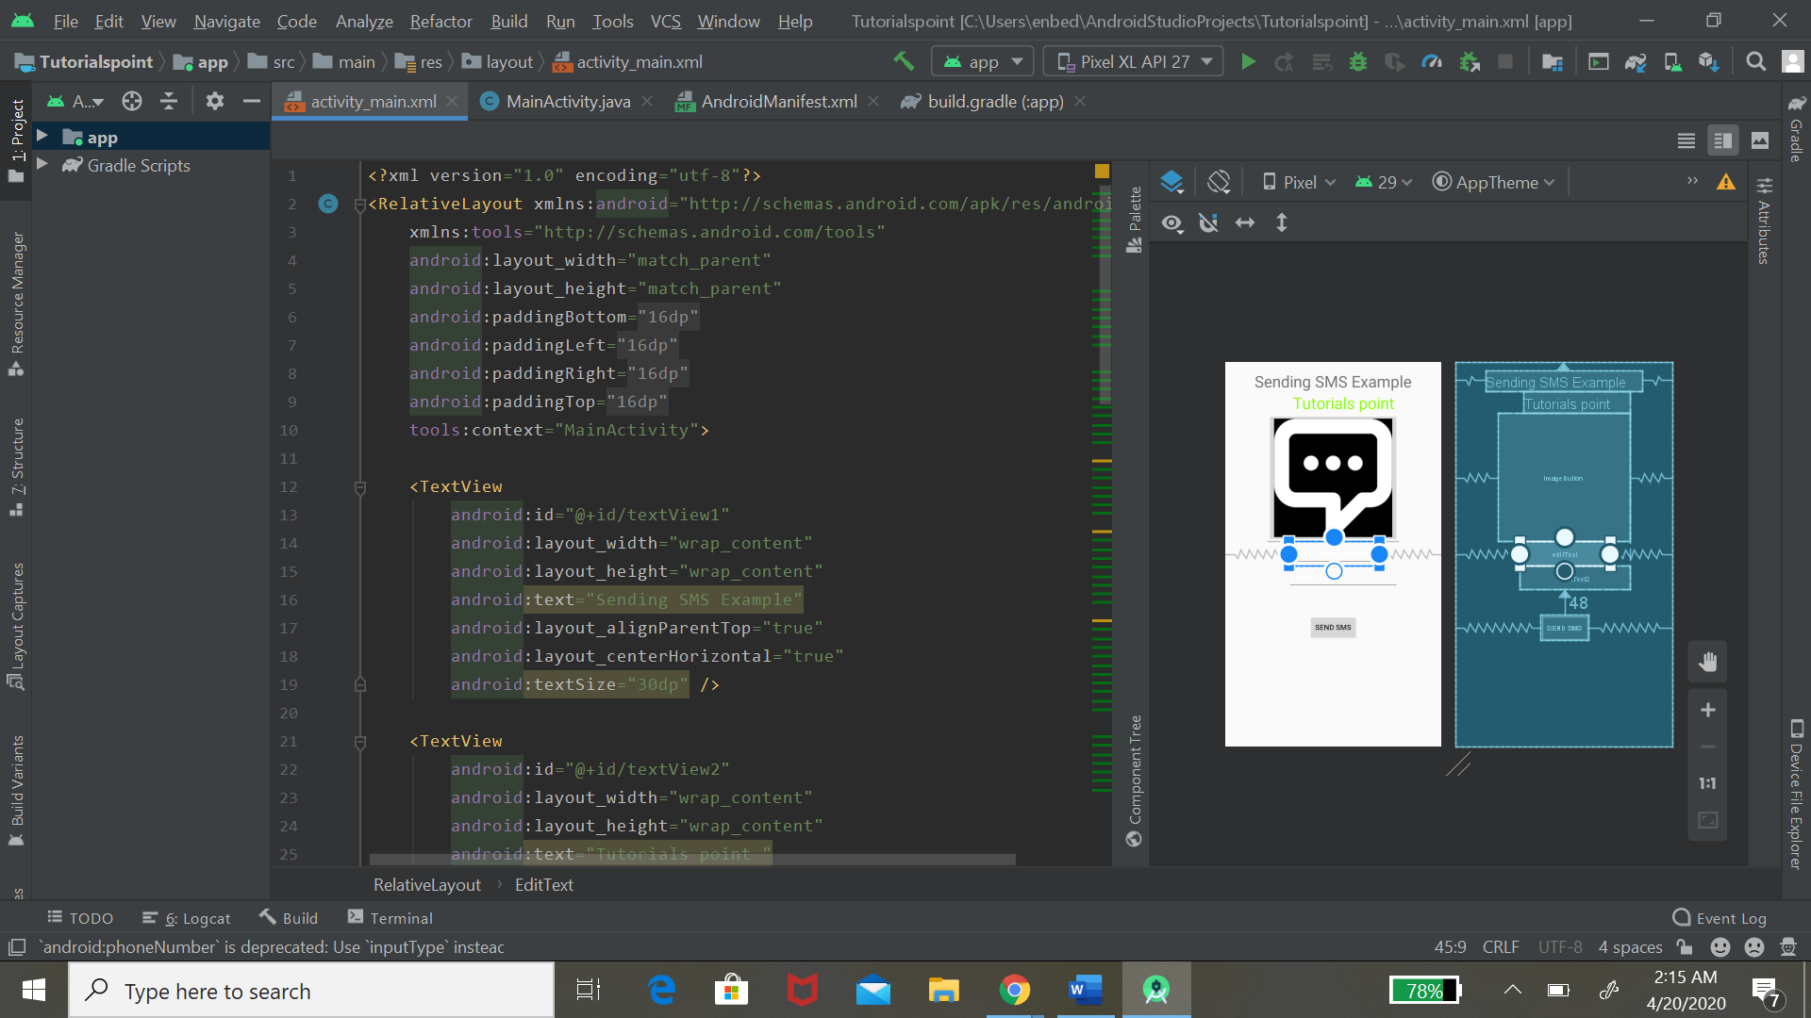

**Implementation of Task 3.**

*4.3.1 Implementation of Subtask 3.1*

*4.3.2 Implementation of Subtask 3.2*

*4.3.3 Implementation of Subtask 3.3*

**Implementation of Design of AI System**

***4.4.1 Implementation of Subtask 4.1-Gather Training Data***

***Detected edges on the sidewalk via OpenCV:*** *My initial approach was to detect the sidewalk edges in multiple frames with computer vision tactics. I worked on OpenCV in python for some time until I switched my focus to deep learning and building a neural network to detect the sidewalk.*

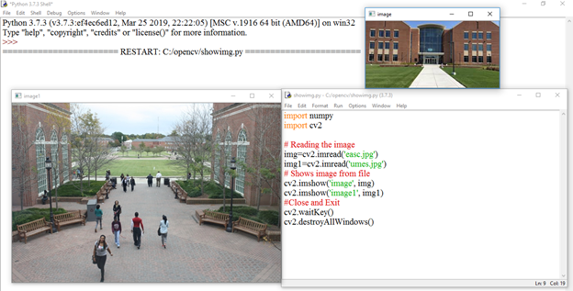

*Figure #: Read and show images using OpenCV. This is the first instance of being introduced to python and its libraries. OpenCV was the first software that I worked on in Designing an Artificial Intelligence System.*

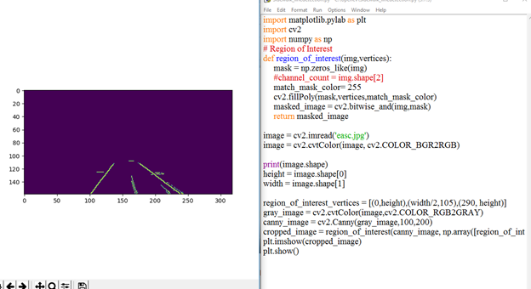

*Figure: This figure shows the source code of canny edge detection that I implemented. My goal was to detect the edges of the Sidewalk,*

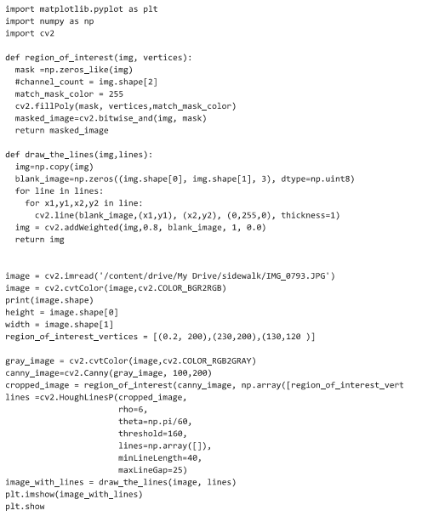

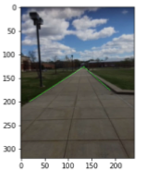

*Figure: Edge detection using OpenCV. This photo shows the edges of the sidewalk being annotated and detected*

***Gathering Data:*** *My first subtask in the object detection deep learning process is to gain a lot of data to be able to train my neural network. Data includes at least 100-1000 images depending on the detection. Gathering data for object detection also includes annotating objects in an image. I have manually captured images with my Iphone camera, sent it to my pc and annotated each frame. This is a time consuming process that required me to gain knowledge on data science.*

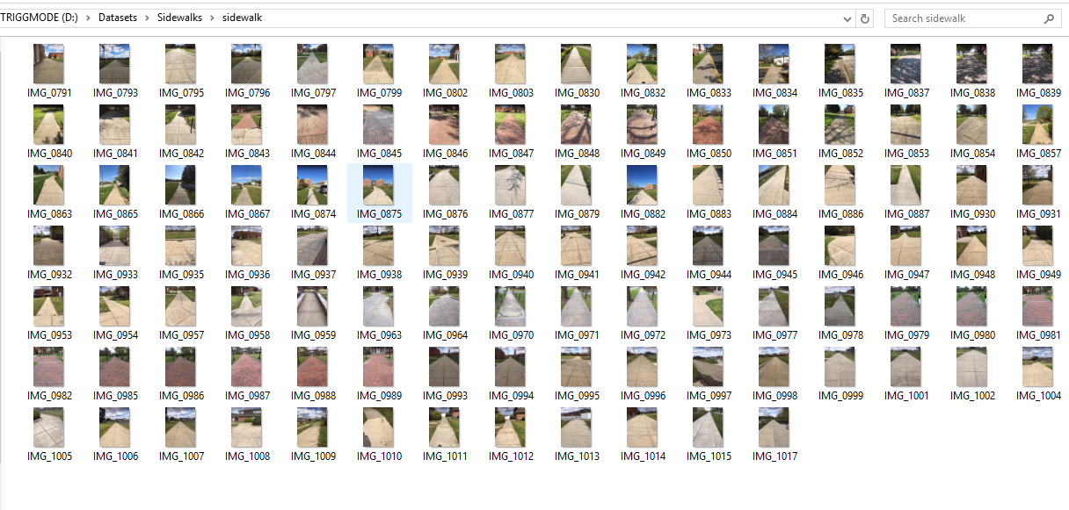

Figure #: This figure shows the first instance of gathering pictures of the UMES campus. I gathered over 300 images in this instance. I decided to delete them because the size was too big to eventually feed in my raspberry pi camera. Not knowing I could have resized in python, I continued to gather more images as you will see in the upcoming figures

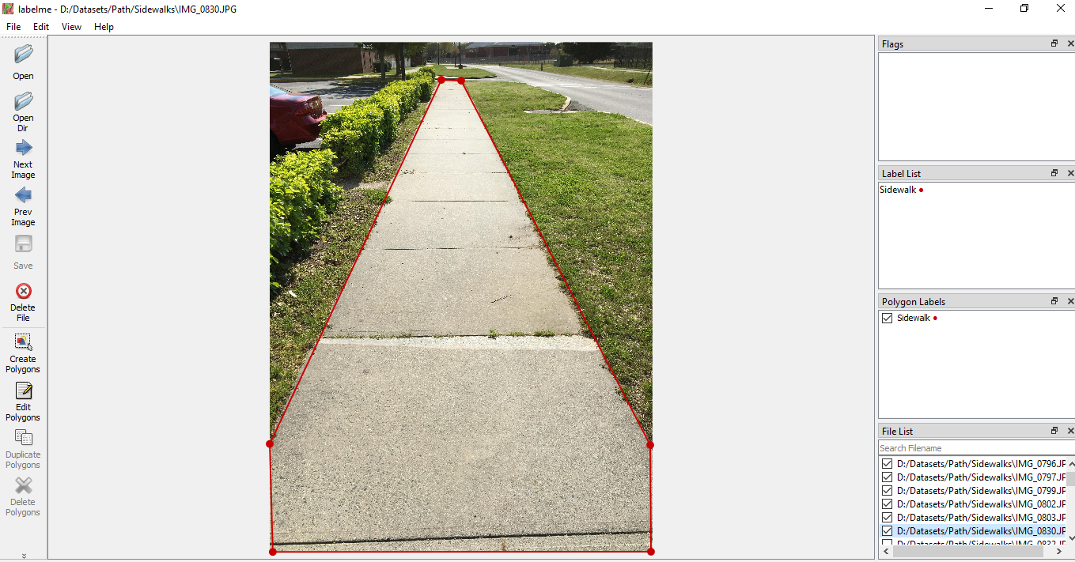

Figure: Annotating Sidewalk using labelme

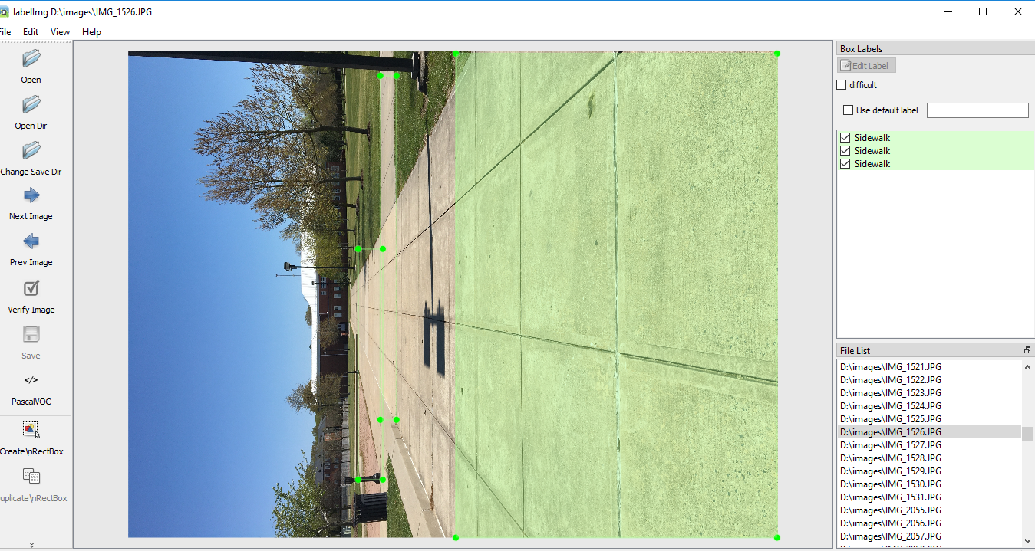

*Figure: Annotating Sidewalk using labeling. This type of annotating is b-box annotating for object detection. This type of annotation was not best suited for my neural network*

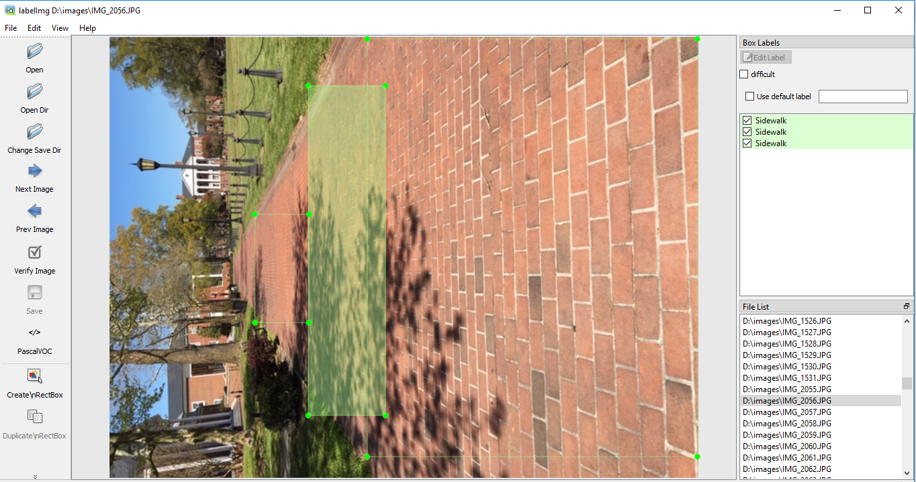

*Figure: Annotating Sidewalks using labelimg. As you can see the figure shows the photo of the sidewalk horizontal and not vertical. So I had to go back to the drawing board making sure that my photos were vertical and had the correct size.*

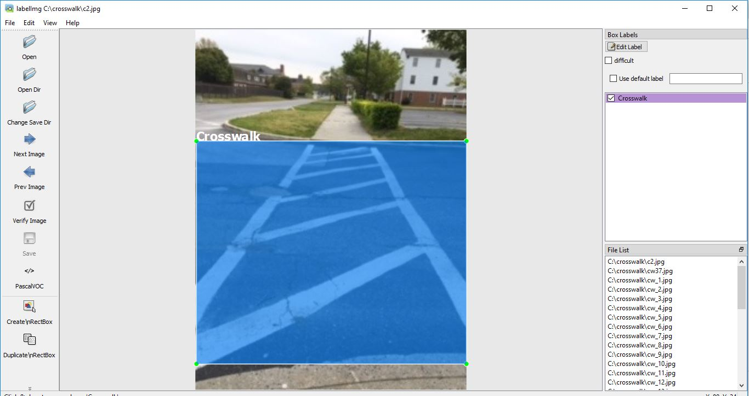

*Figure #: Annotating crosswalks on the UMES Campus. On the campus there is many obstacles between are starting point and the destination point, my goal was to gather data on sidewalks so they can be detected as well.*

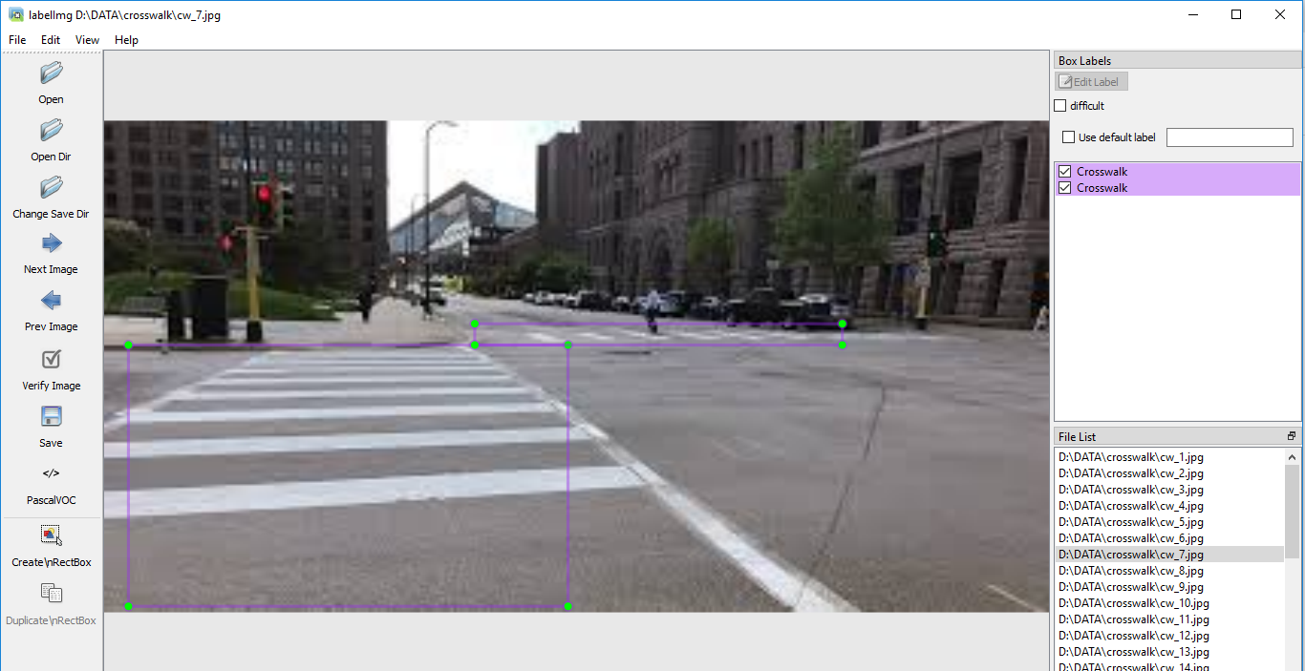

*Figure: Annotating Crosswalks( Picture from google maps)*

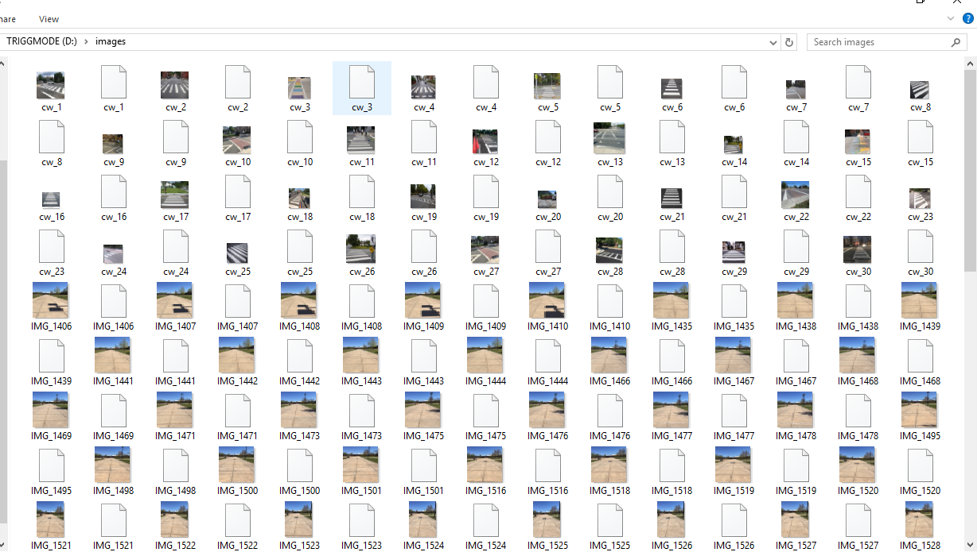

*Figure: Images and xml files*

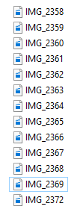

*Figure: 13 manually captured videos from Iphone*

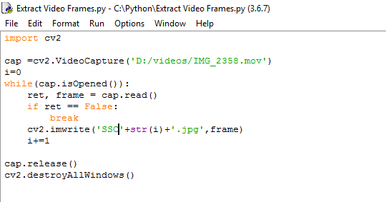

*Figure: Frame Extraction with OpenCV-Python*

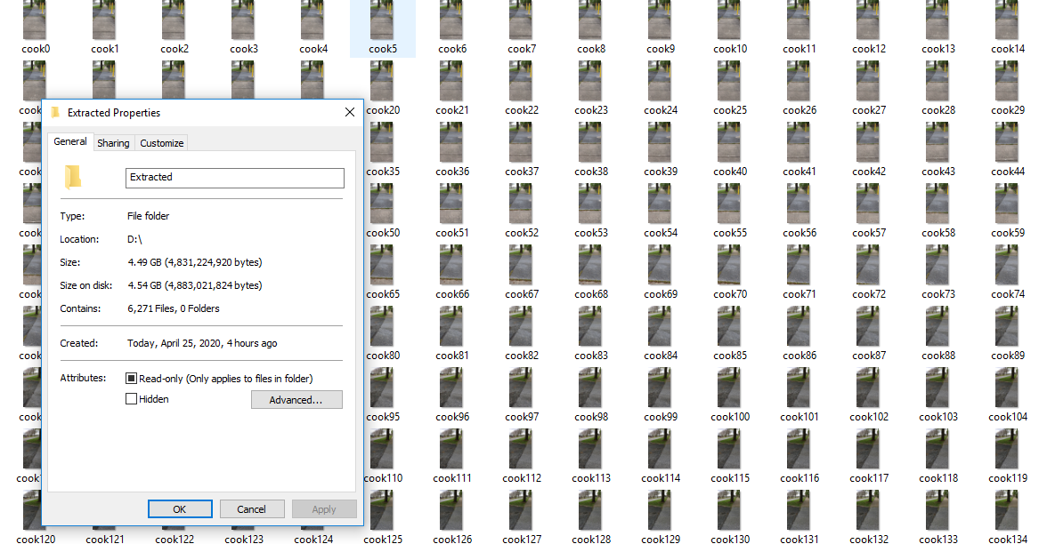

*Figure: 6,271 Extracted video frames*

**Gathering Data:** After realizing that annotating the sidewalk with b-boxes wasn't the best approach for me to take, I decided that semantic segmentation would be the best annotation approach for my data. Semantic segmentation is good for self driving cars and robots because it is good at understanding the context of the environment.

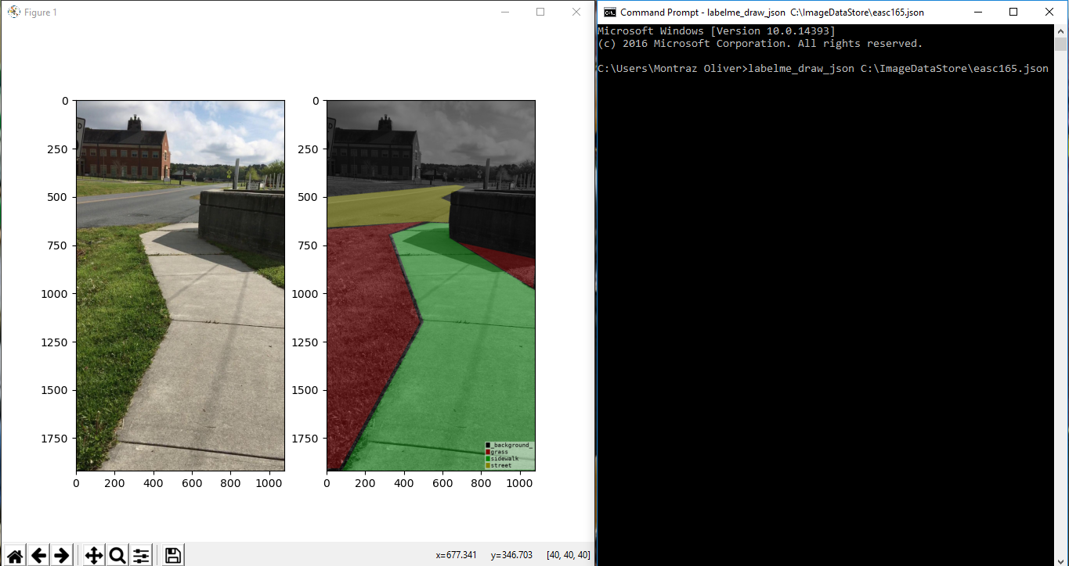

*Figure: JPEG to JSON Image*

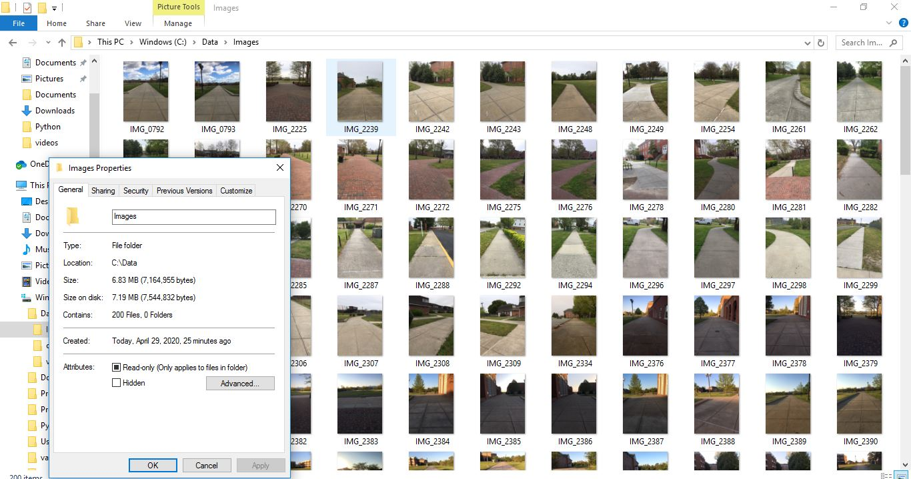

*Figure #: Manually took 200 images of sidewalks around UMES campus from my IPhone. The dimensions of the images are 240 x 320.*

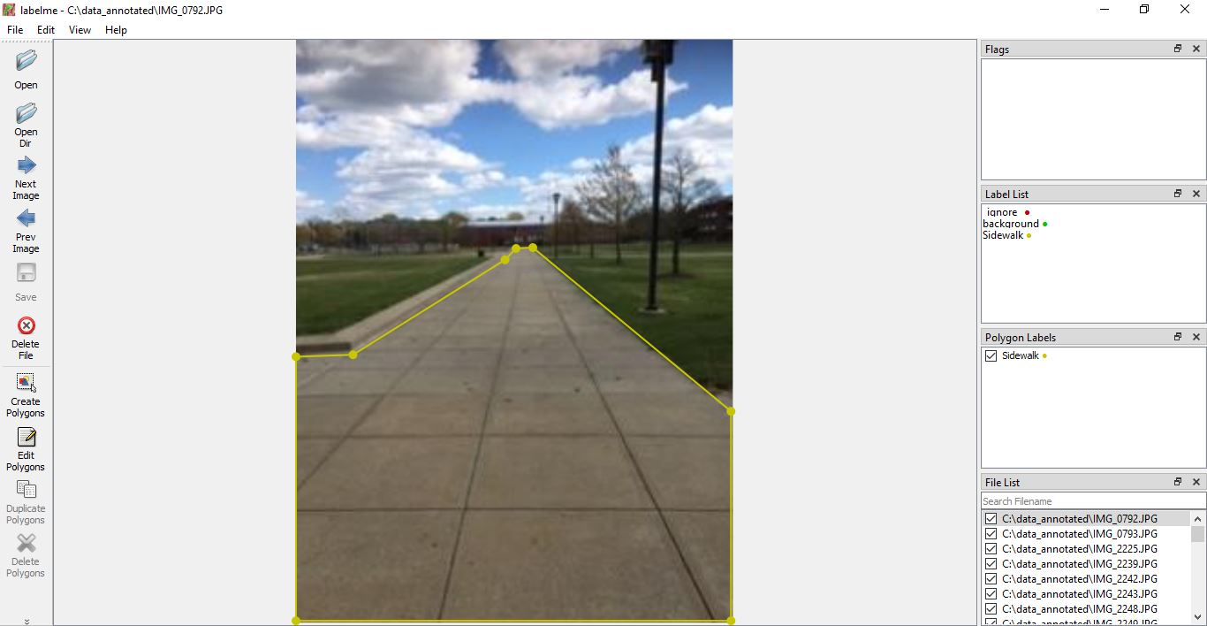

*Figure #: The figure demonstrates the annotation of a sidewalk in the given image. The annotation tool used for the annotation of all the images is labelme. Labelme creates polygons for designated object detection. I placed labels that included: background and sidewalk labeling.This was manually annotated for 200 jpg images.*

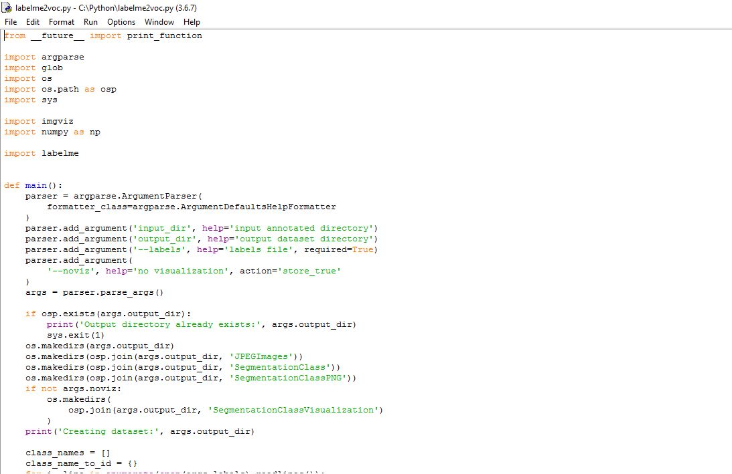

*Figure #: The figure shows an adapted source code from Github to convert the JSON files to an Pascal VOC Dataset.*

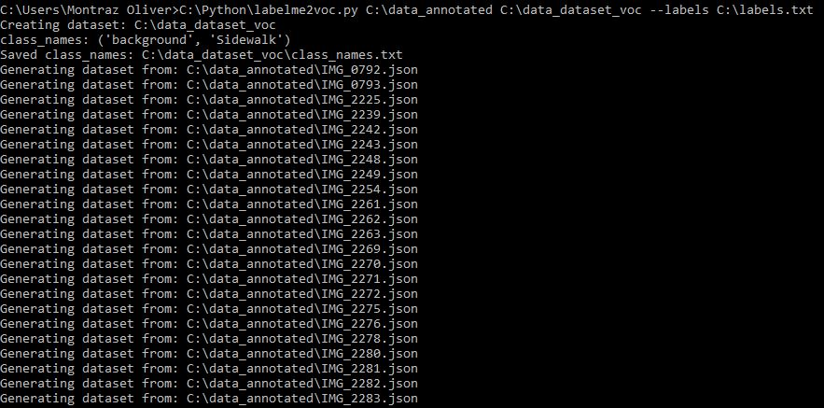

*Figure #: After manually annotating every sidewalk in 200 captured images, the images output was a JSON file. In order to create a dataset of label names and pixel wise masks inside the images, I converted to a voc format dataset. I adapted the labelme to voc conversion source code from Github. After applying the command line in the command prompt , the command prompt generated a JPEG image file, a segmentation class file, a segmentation class png file, a segmentation class visualization file, and a class nemes text file.*

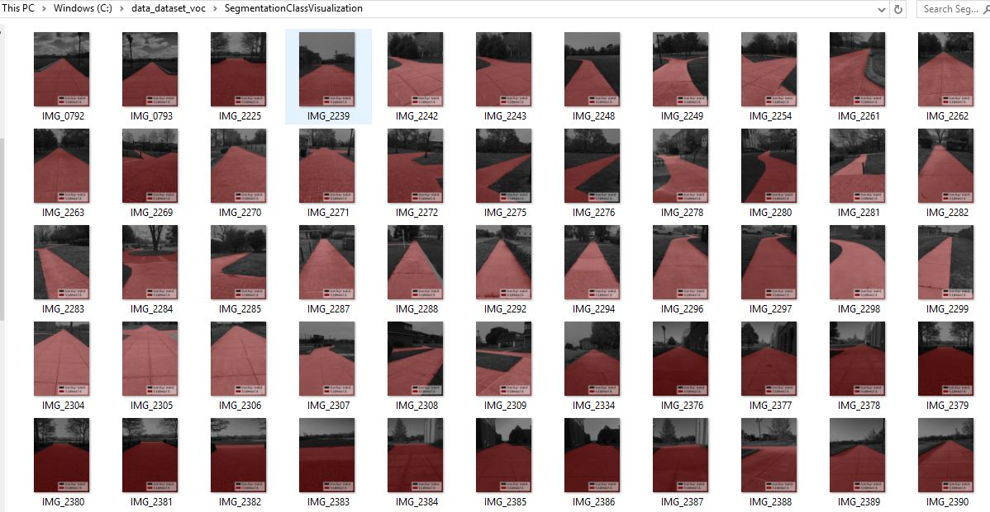

*Figure #: A folder that includes 200 files of a segmentation class visualization. Which includes a visualization of the jpeg image, annotations, and labels.*

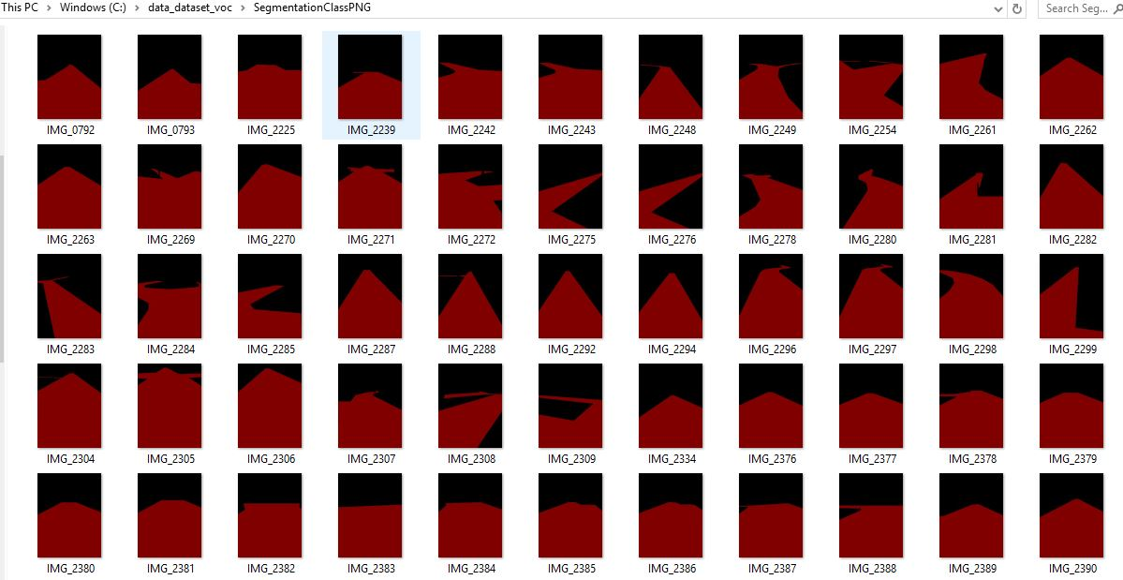

*Figure #: The figure demonstrates a folder that includes 200 PNG files. The png files generate pixel-wise masks of the sidewalks and the background in every image. This data will be used to import 64 % of the files in the training data, 16% of the files in the testing data, and 20% of the files in the validation data for the corresponding neural network dataset.*

***4.4.2 Implementation of Subtask 4.2- Train Model***

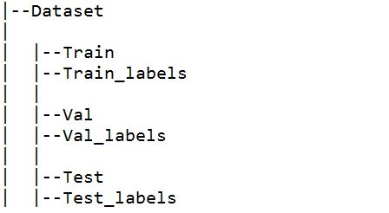

*Figure #: Creating datasets that include training, validation, and test sets. The original dataset including all the jpeg images and segmentation masks in png files are distributed between the three sets. This data is used to be loaded into the neural network. About 64 % of the original data will be used to train the model, 16 % will be used to test the model, 20 % will go to the validation.*

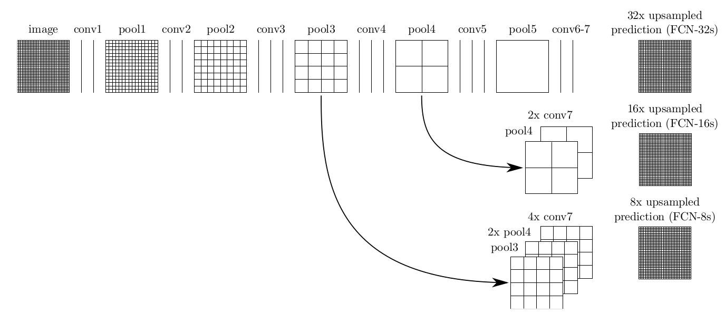

*Figure #: This figure is a direct photo from,* [*www.deeplearning.net*](http://www.deeplearning.net) *. It represents a Fully Convolutional Network Architecture for Semantic Segmentation. The goal is to design FCN-8s for the artificial intelligence system.*

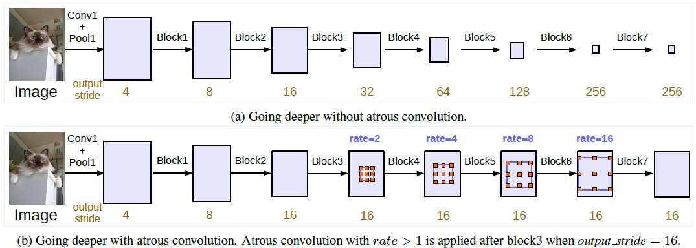

Figure #: This is a model of the DeeplabV3. DeepLab is a state-of-art deep learning model for semantic segmentation. This is also a proposed model I will look to train. This figure is from www.towardsdatascience.com

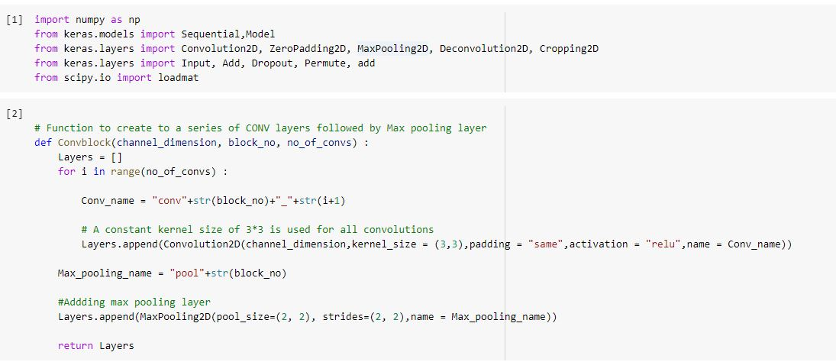

*Figure #: This figure is a portion of an adoption of a FCN for semantic segmentation source code in python. It shows the beginning stages of building an FCN-8s model. It is creating convolutional and max pooling layers so it can fit a FCN 8 architecture model. I look forward to analyzing and reconstructing this source code for my dataset.*

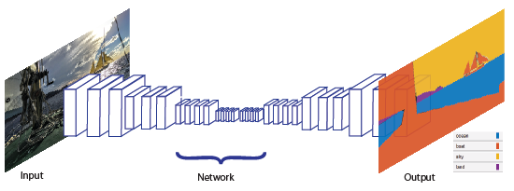

*Figure#: This figure shows the architecture for Semantic Segmentation using matlab. Other than using python as a neural network option, another approach is using matlab software. Which I am much more familiar with than the python language. the architecture is an example of a simple semantic segmentation network This photo is was received by www.mathworks.com*

*4.4.3 Implementation of Subtask 4.3*

*4.4.4 Implementation of Subtask 4.4*

Calculating the Steering angle:

**Implementation of Task 5.**

*4.5.1 Implementation of Subtask 5.1*

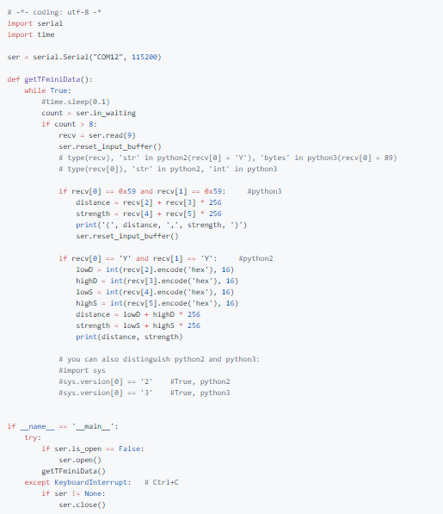 Figure #: This is an adapted code from <https://github.com/TFmini/TFmini-RaspberryPi>. This source code written in python to program the tfmini lidar

*4.5.2 Implementation of Subtask 5.2*

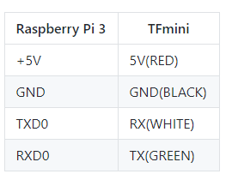

*Figure #: This is a image of table showing the connections of the tf mini lidar with Raspberry Pi 3*

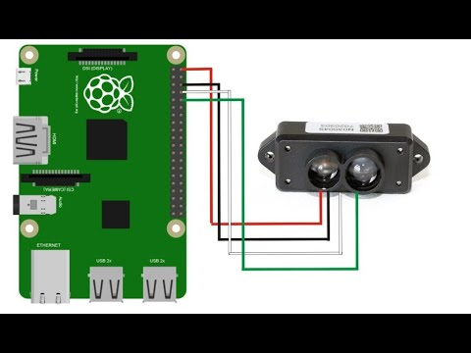

*4.5.3 Implementation of Subtask 5.3*

**Implementation of Task 6.**

For task 6, the goal was to consider How this car is going to be able to navigate to where it needs to go to be able to make its food deliveries .

The first solution that I have looked into was adopting the ardupilot’s solution of the application “Mission Planner” . In mission planner , you have access to satellite maps from Google and Bing and then you can establish waypoints by clicking areas on the map, as seen in the picture i establish 5 waypoints on campus that our delivery vehicle can travel. The issues i came with is trying to run the simulation to test how the vehicle will travel along the waypoints and then return home

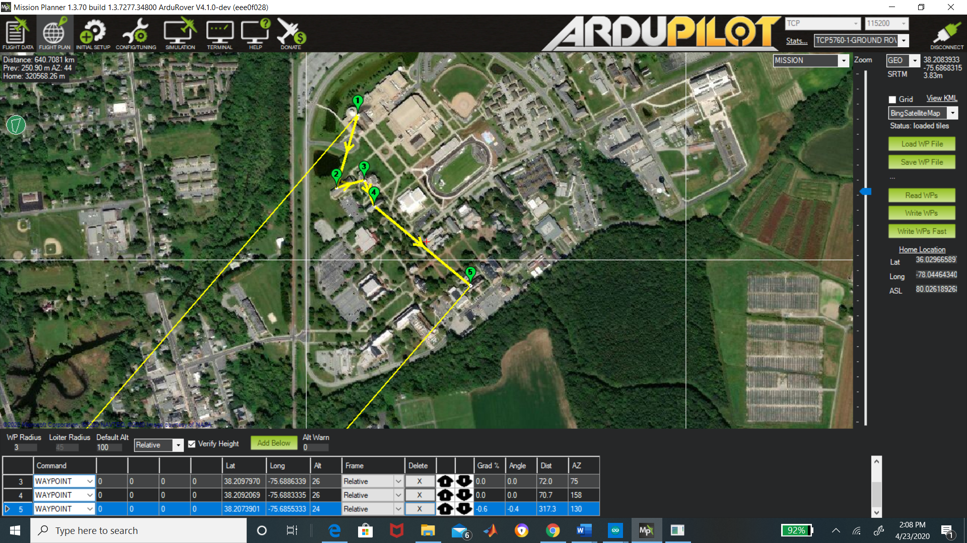

The other solution is accessing using google maps platform “Google API” . Google API gives you access to their satellite and the ability to create a set of waypoints/directions . you're allowed up to 25 waypoints for your personal use. In the code below, there is an example you can call upon these directions with your own personal “API” key. When I enter that code below, Google maps pulls up and then you can set the destination and also places in between that destination. For our vehicle, we want it to travel along the confines of campus, so with google api you can differentiate between if you want a “DRIVING” or “WALKING” route. we will use the walking route because that would avoid the car going on the road.

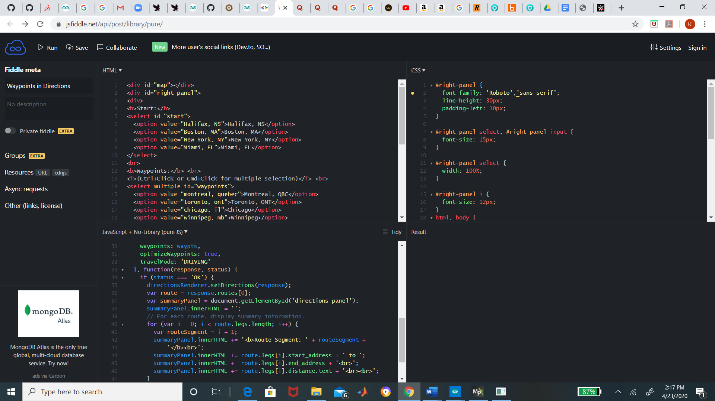

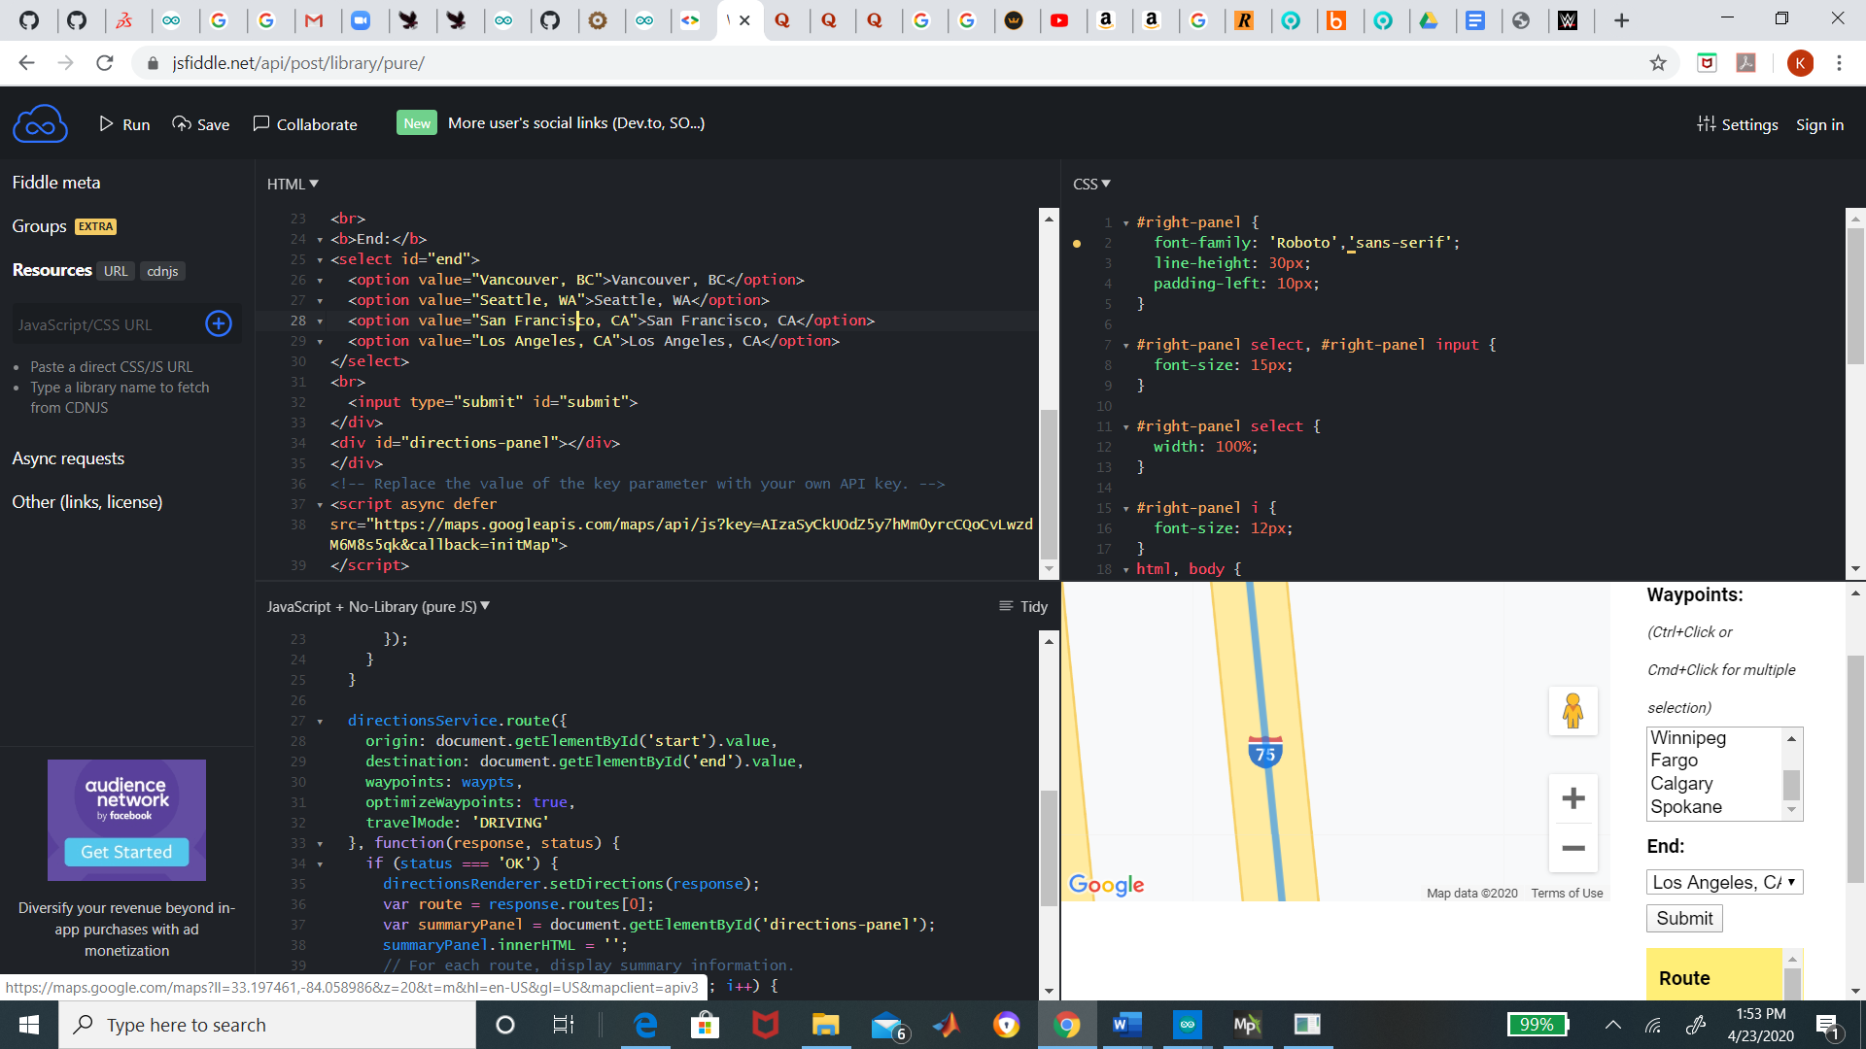

*4.6.1 Implementation of Subtask 6.1*

*4.6.2 Implementation of Subtask 6.2*

*4.6.3 Implementation of Subtask 6.3*

**Implementation of Task 7.**

*4.7.1 Implementation of Subtask 7.1*

*4.7.2 Implementation of Subtask 7.2*

*4.7.3 Implementation of Subtask 7.3*

**CHAPTER 5. PROJECT EVALUATION**

1. Public health
2. Safety
3. Welfare
4. Global Factor
5. Cultural Factor
6. Social Factor
7. Environmental Factor
8. Economic Factor

**CHAPTER 6. CONCLUSION**

**APPENDIX**

**REFERENCES**